**Publish Application**

The next step is to host in IIS 8 (IIS Express). For that use the following procedure:

**Step 1:** In your Solution Explorer select your project and right-click to select Publish.

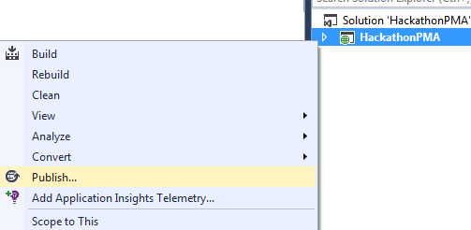

**Step 2:** Select NewProfile and click Next as shown below

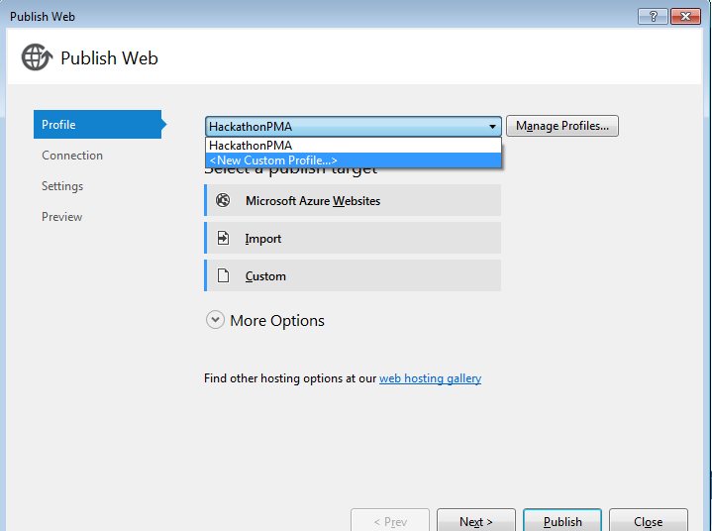

**Step 3:** Enter Profile Name and click OK.

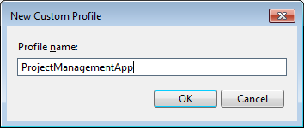

**Step 4:** Select File System in Publish Method and select your preferred location in the Target Folder.

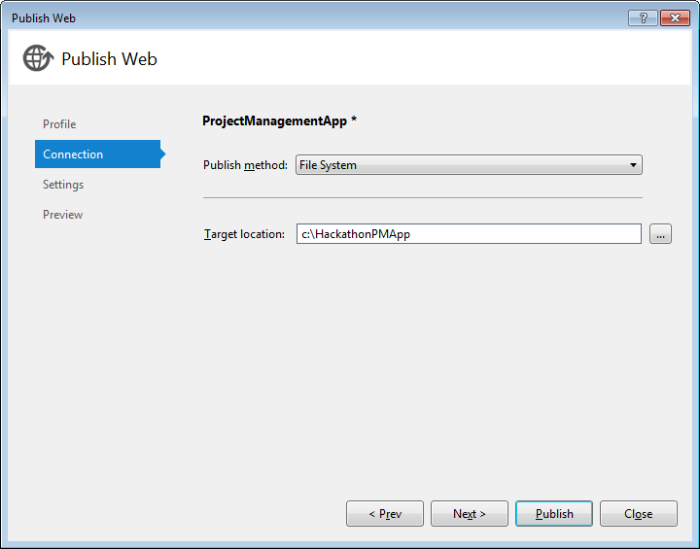

**Step 5:** Select Release in Configuration in the next window and click "Next".

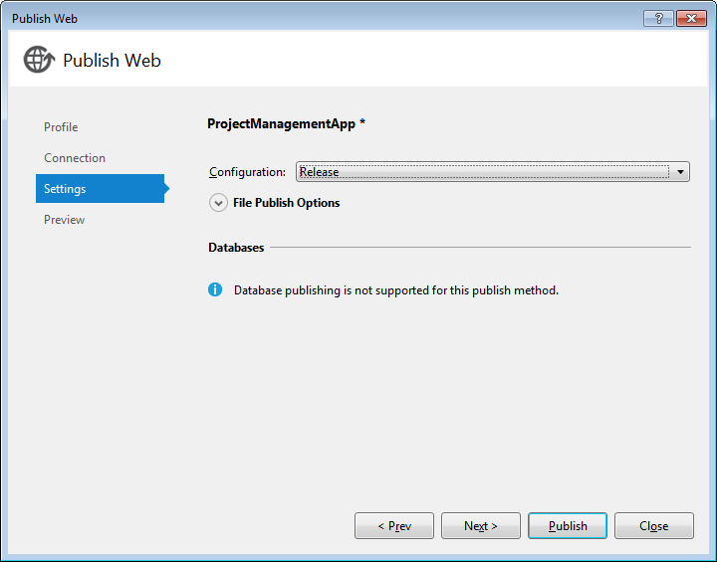

**Step 6:** Click on "Publish" in the next wizard.

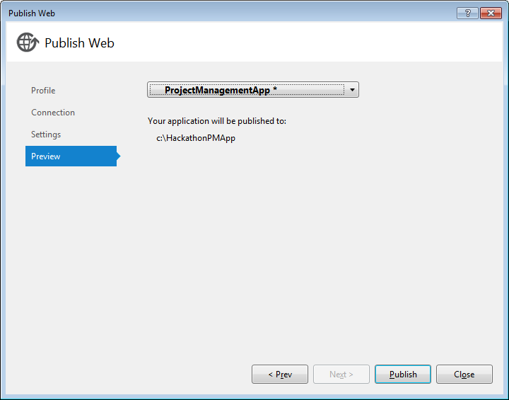

You will see that the application will publish successfully.

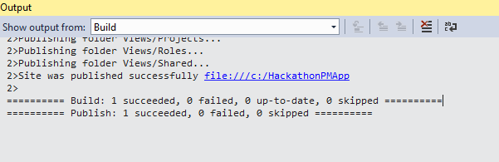

**IIS Host**

Open the Internet Information Services (IIS) Manager and follow the procedure given below.

**Step 1: Open IIS( inetmgr.exe) and create the new Application by right clicking on Default WebSite**

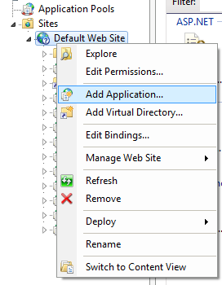

**Step 2: Add the application name and Path of the physical location of the application. (Path where the application was published)**

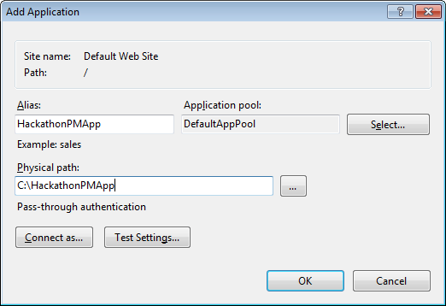

**Step 3**: Click on connect as.. Button. Click on Specific user to allow user to have permission to access the application.

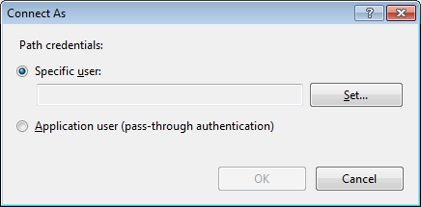

**Step 4:** Enter Machine user name and password and click ok.

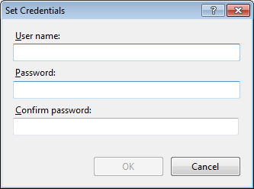

**Step 5: Click on Test Settings.**

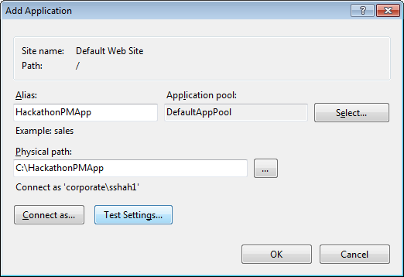

**Step 6:** Window will show if Testing is successful.

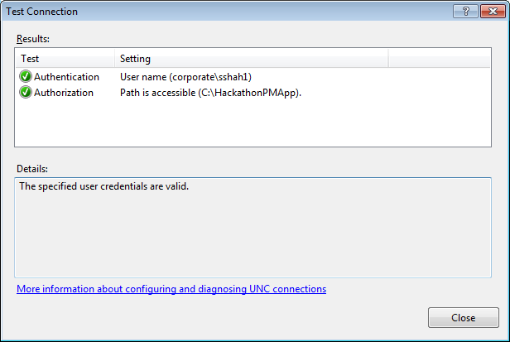

**Step 7: Now select the profile HackathonPMApp and click on browse.**

